
PATUAKHALI SCIENCE AND TECHNOLOGY UNIVERSITY
COURSE CODE CCE-211

SUBMITTED TO:

Prof. Dr. Md Samsuzzaman

Department of Computer and Communication Engineering
Faculty of Computer Science and Engineering

SUBMITTED BY:
Md. Sharafat Karim
ID: 2102024,
Registration No: 10151
Faculty of Computer Science and Engineering

Date of submission: 11 September 2024
Assignment 07
Assignment title: Chapter 05 (Analog Transmission)

Chapter 5 | Quizzes

Define analog transmission.
Analog transmission refers to the method of sending information over a continuous wave signal that varies in amplitude, frequency, or phase to represent the information being sent.
Normally, analog transmission refers to the transmission of analog signals using a band-pass channel. Baseband digital or analog signals are converted to a complex analog signal with a range of frequencies suitable for the channel.

Define carrier signal and explain its role in analog transmission.
A carrier signal is a continuous waveform (usually sinusoidal) that can be modulated by varying its amplitude, frequency, or phase to transmit information in analog transmission. It acts as a vehicle for carrying the data over a communication medium.

Digital-to-Analog Conversion:
Digital-to-analog conversion is the process of changing one of the characteristics of an analog signal based on the information in the digital data
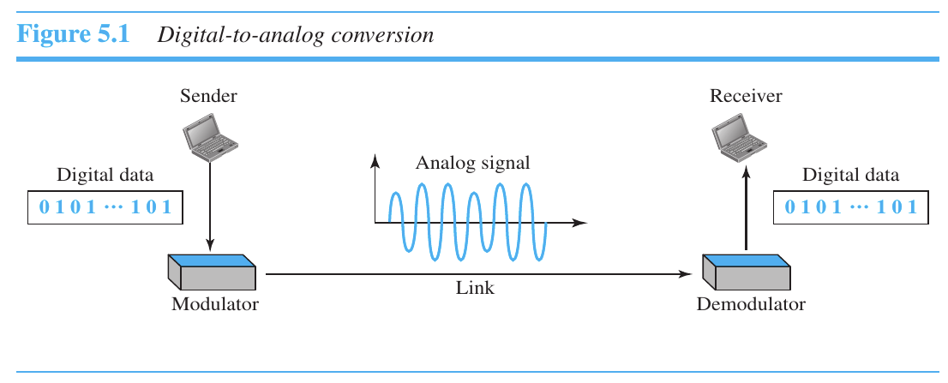

Which characteristics of an analog signal are changed to represent the digital signal in each of the following digital-to-analog conversions?
a. ASK → Amplitude
b. FSK → Frequency
c. PSK → Phase
d. QAM → Amplitude and phase

Which of the four digital-to-analog conversion techniques (ASK, FSK, PSK or QAM) is the most susceptible to noise? Defend your answer.
ASK (Amplitude Shift Keying) is the most susceptible to noise because noise primarily affects the amplitude of a signal, which is directly manipulated in ASK.

Define constellation diagram and explain its role in analog transmission.
A constellation diagram shows us the amplitude and phase of a signal element, particularly when we are using two carriers (one in-phase and one quadrature).
A constellation diagram is a graphical representation of a modulated signal where each point represents a possible symbol that can be transmitted. It is used to visualize the signal's properties like amplitude and phase.

What are the two components of a signal when the signal is represented on a constellation diagram? Which component is shown on the horizontal axis? Which is shown on the vertical axis?
Two components: In-phase (I) and Quadrature (Q).
- The horizontal axis shows the In-phase (I) component.
- The vertical axis shows the Quadrature (Q) component.

Define analog-to-analog conversion.
Analog-to-analog conversion is the process of changing one form of an analog signal into another by modulating its properties like amplitude, frequency, or phase.
Modulation is needed if the medium is bandpass in nature or if only a bandpass channel is available to us.

Which characteristics of an analog signal are changed to represent the lowpass analog signal in each of the following analog-to-analog conversions?
a. AM (Amplitude Modulation): Amplitude of the carrier signal.
b. FM (Frequency Modulation): Frequency of the carrier signal.
c. PM (Phase Modulation): Phase of the carrier signal.

Which of the three analog-to-analog conversion techniques (AM, FM, or PM) is the most susceptible to noise? Defend your answer.
AM (Amplitude Modulation) is the most susceptible to noise because noise primarily affects amplitude, which is the characteristic modulated in AM.

Chapter 5 | Problems

Calculate the baud rate for the given bit rate and type of modulation.
We use the formula , but first we need to calculate the value of r for each case with
a. 2000 bps, FSK
In FSK, each symbol represents one bit, r=1
S= N(1/r)
Thus, the baud rate is equal to the bit rate.
Baud rate = Bit rate
For 2000 bps, FSK: Baud rate = 2000 baud.
b. 4000 bps, ASK
In standard ASK (Binary ASK), each symbol represents one bit, r=1
S=N
For 4000 bps, ASK: Baud rate = 4000 baud.
c. 6000 bps, QPSK
In QPSK, each symbol represents 2 bits, r=2
S= N (1/2)
For 6000 bps, QPSK: Baud rate = 6000 / 2 = 3000 baud.
d. 36,000 bps, 64-QAM
In 64-QAM, each symbol represents 6 bits (since 64 = 2^6), r=6
S= N (1/6)
For 36,000 bps, 64-QAM: Baud rate = 36,000 / 6 = 6000 baud.

Calculate the bit rate for the given baud rate and type of modulation.
We use the formula or, , but first we need to calculate the value of r for each case with
a. 1000 baud, FSK
In FSK, each symbol represents one bit, r=1
N= S*r= 1000*1= 1000
For 1000 baud, FSK: Bit rate = 1000 bps.
b. 1000 baud, ASK
In binary ASK (similar to binary FSK), each symbol represents one bit, r=1
N= S*r= 1000*1= 1000
For 1000 baud, ASK: Bit rate = 1000 bps.
c. 1000 baud, BPSK
In BPSK, each symbol represents one bit, r=1
N= S*r= 1000*1= 1000
For 1000 baud, BPSK: Bit rate = 1000 bps.
d. 1000 baud, 16-QAM
In 16-QAM, each symbol represents 4 bits (since 16 = 2^4), r=4
N= S*r= 1000*4= 4000
For 1000 baud, 16-QAM: Bit rate = 1000 × 4 = 4000 bps.

What is the number of bits per baud for the following techniques?
We use the following formula to calculate the value of r for each case with
a. ASK with four different amplitudes
With four different amplitudes, there are 4 possible signal states.
Bits per baud=log2​(number of amplitudes) =log2​(4) =2 bits per baud
b. FSK with eight different frequencies
With eight different frequencies, there are 8 possible signal states.
Bits per baud=log2​(number of frequencies) =log2​(8) =3 bits per baud
c. PSK with four different phases
With eight different frequencies, there are 4 possible signal states.
Bits per baud=log2​(number of frequencies) =log2​(4) =2 bits per baud
e. QAM with a constellation of 128 points
With 128 points in the constellation, there are 128 possible signal states.
Bits per baud=log2 (number of constellation points) =log2​(128) =7 bits per baud

Draw the constellation diagram for the following:
a. ASK, with peak amplitude values of 1 and 3
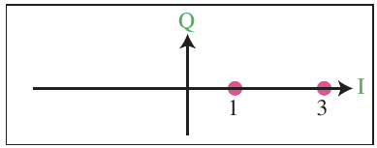
b. BPSK, with a peak amplitude value of 2
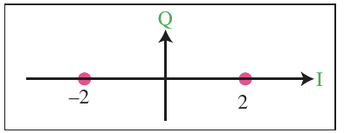
c. QPSK, with a peak amplitude value of 3
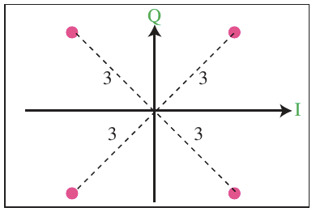
d. 8-QAM with two different peak amplitude values, 1 and 3, and four different phases
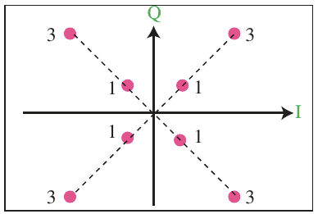

Draw the constellation diagram for the following cases. Find the peak amplitude value for each case and define the type of modulation (ASK, FSK, PSK, or QAM).The numbers in parentheses define the values of I and Q respectively.
a. Two points at (2, 0) and (3, 0)
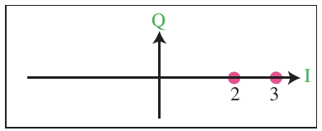
This is ASK. Cause there are two different amplitude with same phase 0. Here peak amplitudes are A1 = 2 and A2 = 3 respectively.
b. Two points at (3, 0) and (−3, 0)
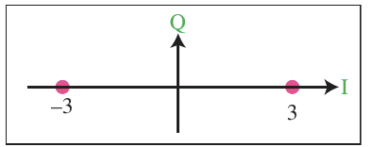
This is BPSK. Here peak amplitudes of the two are same but the phase is different. And it its 180 degree apart.
c. Four points at (2, 2), (−2, 2), (−2, −2), and (2, −2)
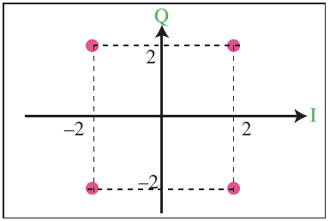
This can be either QPSK (one amplitude, two different phases) or, 4-QAM (one amplitude, two different phases).
QPSK is preferred. Check previous question!

d. Two points at (0, 2) and (0, −2)
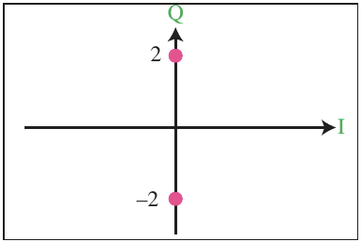
This is BPSK. Here peak are same but the phases are different.

How many bits per baud can we send in each of the following cases if the signal constellation has one of the following number of points?
The number of points define the number of levels, L. The number of bits per baud is the value of r. Therefore, we use the formula r = log₂L for each case.
a. Bits per baud=log2​(2)=1bit per baud
b. Bits per baud=log2​(4)=2bits per baud
c. Bits per baud=log2​(16)=4bits per baud
d. Bits per baud=log2​(1024)=10bits per baud

What is the required bandwidth for the following cases if we need to send 4000 bps? Let d = 1.
We use the formula B = (1 + d) x ()x N
but first we need the value of r for each case.
a. ASK
r = 1, B = ( 1 + 1 ) x ( 1 / 1) x 4000 bps = 8000 Hz
b. FSK with 2Δf = 4 KHz
r = 1, B = ( 1 + 1 ) x ( 1 / 1) x 4000 bps + 4000 = 12000 Hz
c. QPSK
r = 2, B = ( 1 + 1 ) x ( 1 / 2) x 4000 bps = 4000 Hz
d. 16-QAM
r = 4, B = ( 1 + 1 ) x ( 1 / 4) x 4000 bps = 2000 Hz

P5-8. The telephone line has 4 KHz bandwidth. What is the maximum number of bits we can send using each of the following techniques? Let d = 0
We use the formula
But first we need the value of r for each case.
a. ASK
r = log₂2=1, N = [1/(1+0)]x1x4 kHz = 4 kbps
b. QPSK
r = log₂4=2, N = [1/(1+0)]x2x4 kHz = 8 kbps
c. 16- QAM
r = log₂16=4, N = [1/(1+0)]x4x4 kHz = 16 kbps
d.64-QAM
r = log₂64=6, N = [1/(1+0)]x6x4 kHz = 24 kbps

A corporation has a medium with a 1-MHz bandwidth (lowpass). The corpo ration needs to create 10 separate independent channels each capable of send ing at least 10 Mbps. The company has decided to use QAM technology. What is the minimum number of bits per baud for each channel? What is the number of points in the constellation diagram for each channel? Let d = 0.
First, we calculate the bandwidth for each channel = (1 MHz) / 10 = 100 KHz. We then find the value of r for each channel:
B = (1 + d) × (1/r) × (N)
→ r = N / B
→ r = (1 Mbps/100 KHz) = 10
We can then calculate the number of levels: L = 2^{r} = 2¹⁰ = 1024. This means that that we need a 1024-QAM technique to achieve this data rate.

A cable company uses one of the cable TV channels (with a bandwidth of 6 MHz) to provide digital communication for each resident. What is the available data rate for each resident if the company uses a 64-QAM technique?
We use the formula
But first we need the value of r.
r = log₂64=6, N = [1/(1+0)]x6x6 MHz = 36 Mbps

Find the bandwidth for the following situations if we need to modulate a 5-KHz voice.
a.AM
B_{AM} = 2 × B = 2 × 5 = 10 KHz
b. FM(β = 5)
B_{FM} = 2 × (1 + β) × B = 2 × (1 + 5) × 5 = 60 kHz
c. PM(β = 1)
B_{PM} = 2 × (1 + β) × B = 2 × (1 + 1) × 5 = 20 KHz

Find the total number of channels in the corresponding band allocated by FCC.
We calculate the number of channels, not the number of coexisting stations.
a. AM
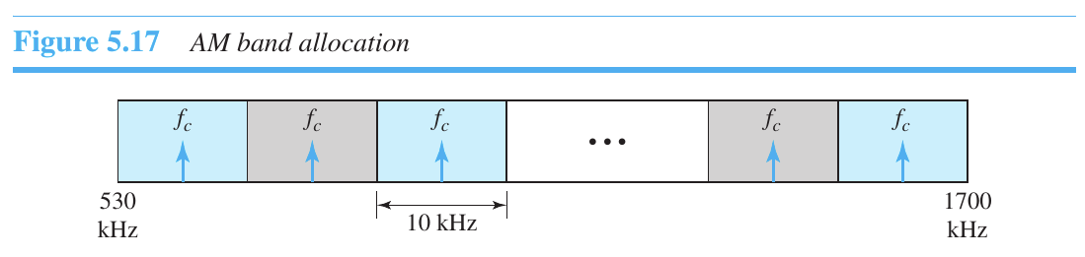
Number of channel, n = (1700 - 530) KHz / 10 KHz = 117
b. FM
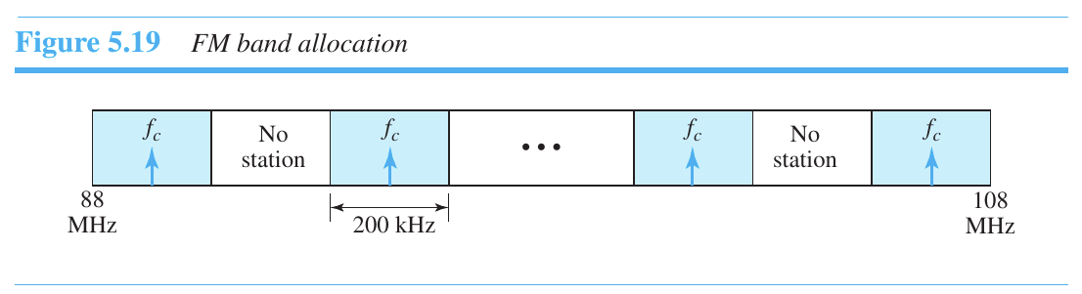
Number of channel, n = (108 - 88) MHz / 200 KHz =100

